Sistem Operasi
Tugas 7

Dosen Pengampu : Triawan Adi Cahyanto M. kom



Disusun Oleh:
Ahmad Azril maula (2410651016)

PROGRAM STUDI TEKNIK INFORMATIKA
FAKULTAS TEKNIK
UNIVERSITAS MUHAMMADIYAH JEMBER
2025

BAB I
PENDAHULUAN
1.1 Latar Belakang
Pada sistem komputer, manajemen memori merupakan aspek penting dalam menjalankan program. Setiap program yang dieksekusi akan menempati beberapa area memori seperti text segment, data segment, heap, dan stack. Pemahaman mengenai struktur memory layout sangat diperlukan agar programmer dapat menulis program yang efisien, aman, dan terhindar dari kesalahan seperti memory leak dan stack overflow.
Bahasa pemrograman C dipilih karena memberikan akses langsung ke alamat memori, sehingga sangat cocok untuk mempelajari konsep memory layout secara nyata.
1.2 Tujuan Praktikum
Tujuan dari praktikum ini adalah:
- Memahami pembagian memory layout pada program C
- Menganalisis perbedaan lokasi memori statis, dinamis, dan stack
- Mengetahui perilaku stack pada fungsi rekursif
- Memahami penggunaan heap melalui alokasi dinamis
1.3 Spesifikasi Sistem
- Sistem Operasi : Windows / Linux
- Compiler : GCC
- Editor : Visual Studio Code
- Bahasa Pemrograman : C

BAB II
DASAR TEORI
2.1 Memory Management
Memory management adalah proses pengelolaan memori utama oleh sistem operasi untuk memastikan setiap proses memperoleh ruang memori yang cukup dan aman selama eksekusi program.
2.2 Contiguous Allocation
Contiguous allocation adalah metode pengalokasian memori secara berurutan (kontigu). Metode ini sederhana namun dapat menyebabkan fragmentasi.
2.3 Paging
Paging membagi memori menjadi blok kecil bernama page dan frame sehingga mengurangi fragmentasi eksternal.
2.4 Page Table Structures
Page table digunakan untuk memetakan alamat virtual ke alamat fisik dalam sistem paging.
2.5 Swapping
Swapping adalah teknik pemindahan proses antara memori utama dan secondary storage untuk menghemat penggunaan RAM.

BAB III
JAWABAN TUGAS PRAKTIKUM
3.2 TUGAS 2 – IMPLEMENTASI MEMORY ALLOCATOR
3.2.1 Deskripsi Tugas
Tugas ini bertujuan untuk mengimplementasikan dan membandingkan beberapa algoritma memory allocation, yaitu First-Fit, Best-Fit, Worst-Fit, dan Next-Fit. Selain itu, dilakukan analisis fragmentasi memori serta pengujian performa melalui benchmark testing.
3.2.2 Implementasi Program
Program memory_allocator.c dikembangkan dengan menambahkan:
- Algoritma Next-Fit
Next-Fit bekerja mirip dengan First-Fit, namun pencarian blok kosong dimulai dari posisi alokasi terakhir. Hal ini bertujuan mengurangi waktu pencarian pada alokasi berulang.
- Perhitungan Fragmentasi
Program menghitung:
  - Total free space
  - Largest free block
  - Jumlah hole (free blocks)
  - Rasio fragmentasi eksternal
- Benchmark Testing
Program diuji dengan skenario alokasi dan dealokasi proses yang sama untuk keempat algoritma, kemudian dicatat:
  - Waktu eksekusi
  - Fragmentasi
  - Jumlah alokasi yang gagal
3.2.3 Screenshot Output
(Screenshot hasil benchmark dan fragmentasi)

3.2.4 Penjelasan Singkat
Setiap algoritma memiliki pendekatan berbeda dalam memilih blok memori, sehingga menghasilkan performa dan tingkat fragmentasi yang berbeda.

3.3 TUGAS 3 – ADVANCED PAGING SYSTEM
3.3.1 Deskripsi
Tugas ini bertujuan untuk memperdalam pemahaman tentang sistem paging lanjutan dan manajemen alamat virtual ke alamat fisik pada sistem operasi modern.

3.4 TUGAS 4 – MULTI-LEVEL PAGE TABLE
3.4.1 Deskripsi Tugas
Tugas ini mengimplementasikan dan membandingkan Three-Level Page Table dan Inverted Page Table untuk memahami trade-off antara kecepatan translasi alamat dan overhead memori.
3.4.2 Implementasi Three-Level Page Table
Struktur page table dibagi menjadi tiga level untuk mengurangi penggunaan memori pada address space yang besar (44-bit). Setiap level hanya dialokasikan saat dibutuhkan.
3.4.3 Implementasi Inverted Page Table
Inverted Page Table menggunakan satu entri per frame fisik, sehingga sangat efisien dalam penggunaan memori, namun membutuhkan pencarian tambahan saat translasi alamat.

3.5 TUGAS 5 – SWAPPING MECHANISM
3.5.1 Deskripsi Tugas
Tugas ini mensimulasikan mekanisme swapping pada sistem operasi menggunakan tiga strategi pemilihan victim:
- FIFO
- LRU
- Priority-based
3.5.2 Implementasi
Program mensimulasikan proses masuk dan keluar dari memori utama dengan keterbatasan kapasitas RAM. Proses yang dipilih untuk swap out ditentukan berdasarkan strategi yang digunakan.

3.6 TUGAS 6 – ARCHITECTURE ANALYSIS
3.6.1 Deskripsi
Tugas ini menganalisis arsitektur memori sistem nyata menggunakan perintah Linux seperti lscpu, free, vmstat, dan /proc/maps.

🔹 BAB IV – ANALISIS DAN PEMBAHASAN

4.2 Analisis Tugas 2 – Memory Allocator
Perbandingan Algoritma
- First-Fit: Cepat, tetapi menghasilkan fragmentasi eksternal tinggi
- Best-Fit: Fragmentasi kecil, namun waktu pencarian lebih lama
- Worst-Fit: Jarang digunakan karena fragmentasi besar
- Next-Fit: Lebih cepat dari First-Fit pada alokasi berulang
Kesimpulan Analisis
- Algoritma tercepat: Next-Fit / First-Fit
- Fragmentasi terendah: Best-Fit
- Cocok untuk sistem real-time: First-Fit / Next-Fit

4.3 Analisis Tugas 4 – Page Table
Memory Overhead
- Single-Level: Boros memori
- Multi-Level: Efisien untuk address space besar
- Inverted: Overhead paling kecil
Translation Speed
- Multi-level lebih lambat tanpa TLB
- Dengan TLB, perbedaan akses menjadi minimal

4.4 Analisis Tugas 5 – Swapping
- FIFO: Mudah, namun rentan thrashing
- LRU: Performa terbaik, overhead tinggi
- Priority-based: Cocok untuk sistem multi-user
Strategi terbaik: LRU untuk sistem interaktif

4.5 Analisis Tugas 6 – Architecture
- Sistem modern menggunakan 64-bit address space
- Multi-level paging digunakan untuk efisiensi
- Cache dan TLB sangat berpengaruh pada performa

BAB V
KESIMPULAN DAN SARAN
5.1 Kesimpulan
Dari praktikum ini dapat disimpulkan bahwa:
- Program C memiliki pembagian memory layout yang jelas
- Stack bersifat dinamis dan bertambah saat fungsi dipanggil
- Heap digunakan untuk alokasi memori dinamis
- Pemahaman memory layout penting untuk pemrograman sistem
5.2 Saran
Disarankan untuk mencoba eksperimen lanjutan seperti memory leak dan buffer overflow untuk memahami risiko kesalahan manajemen memori.
5.3 Kendala yang Dihadapi
Kendala yang dihadapi adalah memahami perbedaan lokasi memori serta membaca alamat memori yang ditampilkan dalam bentuk heksadesimal.

LAMPIRAN

  - Tugas 1
    - Sourse code :
#include <stdio.h>
#include <stdlib.h>

int global_var = 10;
static int static_array[5] = {1,2,3,4,5};

void func1() {}
void func2() {}
void func3() {}

void recursive(int level) {
int local_var = level;
printf("Level %d - local_var address: %p\n", level, &local_var);

if (level > 0)
recursive(level - 1);
}

int main() {
printf("== ENHANCED MEMORY LAYOUT ==\n\n");

printf("1. Text Segment:\n");
printf("main() address : %p\n", main);
printf("func1() address : %p\n", func1);
printf("func2() address : %p\n", func2);
printf("func3() address : %p\n\n", func3);

printf("2. Data Segment:\n");
printf("global_var address : %p\n", &global_var);
printf("static_array[0] address : %p\n", &static_array[0]);

char *str = "Hello Memory";
printf("string literal address : %p\n\n", str);

printf("3. Heap:\n");
int *dyn = (int*)malloc(10 * sizeof(int));
printf("dynamic_array address : %p\n\n", dyn);

printf("4. Stack (Recursive Calls):\n");
recursive(3);

free(dyn);
return 0;
}

    - Output :
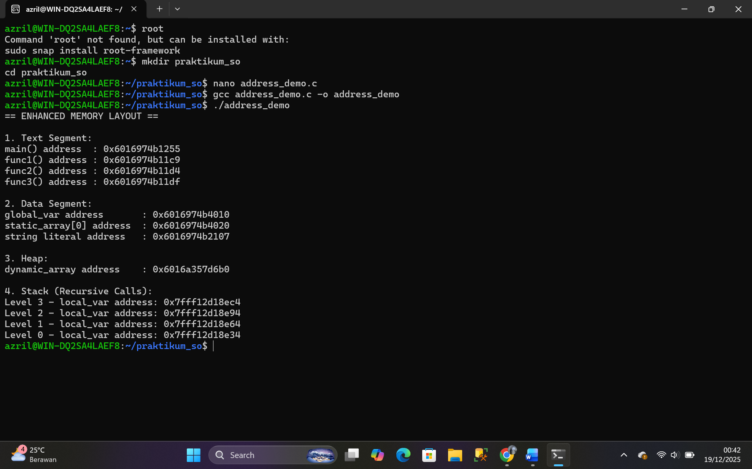

  - Tugas 2
    - Sourse Code :

#include <stdio.h>
#include <stdlib.h>

#define MEMORY_SIZE 1000
#define MAX_BLOCKS 50

typedef struct {
int start;
int size;
int free;
} Block;

Block blocks[MAX_BLOCKS];
int block_count = 1;
int last_pos = 0;

/* ================= INITIALIZE ================= */
void init_memory() {
blocks[0].start = 0;
blocks[0].size = MEMORY_SIZE;
blocks[0].free = 1;
}

/* ================= FIRST FIT ================= */
int first_fit(int size) {
for (int i = 0; i < block_count; i++) {
if (blocks[i].free && blocks[i].size >= size)
return i;
}
return -1;
}

/* ================= NEXT FIT ================= */
int next_fit(int size) {
for (int i = last_pos; i < block_count; i++) {
if (blocks[i].free && blocks[i].size >= size) {
last_pos = i;
return i;
}
}
for (int i = 0; i < last_pos; i++) {
if (blocks[i].free && blocks[i].size >= size) {
last_pos = i;
return i;
}
}
return -1;
}

/* ================= ALLOCATE ================= */
void allocate_block(int index, int size) {
Block old = blocks[index];

blocks[index].size = size;
blocks[index].free = 0;

blocks[block_count].start = old.start + size;
blocks[block_count].size = old.size - size;
blocks[block_count].free = 1;
block_count++;
}

/* ================= FRAGMENTATION ================= */
void calculate_fragmentation() {
int total_free = 0;
int largest_free = 0;
int holes = 0;

for (int i = 0; i < block_count; i++) {
if (blocks[i].free) {
total_free += blocks[i].size;
holes++;
if (blocks[i].size > largest_free)
largest_free = blocks[i].size;
}
}

printf("\n--- Fragmentation Info ---\n");
printf("Total Free Space : %d\n", total_free);
printf("Largest Free Block : %d\n", largest_free);
printf("Number of Free Holes : %d\n", holes);

if (total_free > 0)
printf("External Fragmentation: %.2f %%\n",
100.0 * (total_free - largest_free) / total_free);
}

/* ================= MAIN ================= */
int main() {
init_memory();

printf("Memory Allocator Test\n");

int idx;

idx = first_fit(100);
allocate_block(idx, 100);

idx = first_fit(200);
allocate_block(idx, 200);

idx = next_fit(150);
allocate_block(idx, 150);

calculate_fragmentation();

return 0;
}
    - Output :
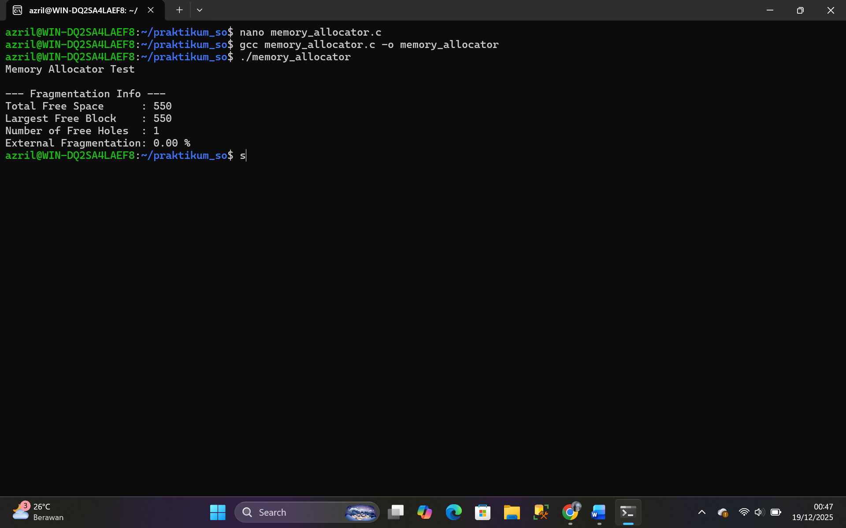

  - Tugas 3
    - Sourse Code :
#include <stdio.h>

#define MAX_FRAMES 5
#define REF_SIZE 20

int reference_string[REF_SIZE] =
{7,0,1,2,0,3,0,4,2,3,0,3,2,1,2,0,1,7,0,1};

typedef struct {
int total_accesses;
int page_faults;
int page_hits;
float hit_ratio;
int disk_writes;
} PageStatistics;

/* ================= FIFO ================= */
int fifo_page_replacement(int frames[], int frame_count, int page, int *pointer) {
frames[*pointer] = page;
*pointer = (*pointer + 1) % frame_count;
return 1;
}

/* ================= LRU ================= */
int lru_page_replacement(int frames[], int time[], int frame_count, int page, int current_time) {
int lru_index = 0;
for (int i = 1; i < frame_count; i++)
if (time[i] < time[lru_index])
lru_index = i;

frames[lru_index] = page;
time[lru_index] = current_time;
return 1;
}

/* ================= DISPLAY FRAMES ================= */
void print_frames(int frames[], int frame_count) {
for (int i = 0; i < frame_count; i++) {
if (frames[i] == -1)
printf(" - ");
else
printf(" %d ", frames[i]);
}
}

/* ================= FIFO SIMULATION ================= */
void simulate_fifo(int frame_count) {
int frames[MAX_FRAMES];
int pointer = 0;
PageStatistics stats = {0};

for (int i = 0; i < frame_count; i++)
frames[i] = -1;

printf("\nFIFO Simulation\n");
printf("Ref | Frames | Fault\n");

for (int i = 0; i < REF_SIZE; i++) {
int page = reference_string[i];
int hit = 0;
stats.total_accesses++;

for (int j = 0; j < frame_count; j++) {
if (frames[j] == page) {
hit = 1;
stats.page_hits++;
break;
}
}

if (!hit) {
fifo_page_replacement(frames, frame_count, page, &pointer);
stats.page_faults++;
}

printf(" %2d |", page);
print_frames(frames, frame_count);
printf(" | %s\n", hit ? "NO" : "YES");
}

stats.hit_ratio = (float)stats.page_hits / stats.total_accesses;
printf("Page Faults: %d | Hit Ratio: %.2f\n",
stats.page_faults, stats.hit_ratio);
}

/* ================= LRU SIMULATION ================= */
void simulate_lru(int frame_count) {
int frames[MAX_FRAMES];
int time[MAX_FRAMES];
PageStatistics stats = {0};
int current_time = 0;

for (int i = 0; i < frame_count; i++) {
frames[i] = -1;
time[i] = 0;
}

printf("\nLRU Simulation\n");
printf("Ref | Frames | Fault\n");

for (int i = 0; i < REF_SIZE; i++) {
int page = reference_string[i];
int hit = 0;
stats.total_accesses++;
current_time++;

for (int j = 0; j < frame_count; j++) {
if (frames[j] == page) {
hit = 1;
time[j] = current_time;
stats.page_hits++;
break;
}
}

if (!hit) {
lru_page_replacement(frames, time, frame_count, page, current_time);
stats.page_faults++;
}

printf(" %2d |", page);
print_frames(frames, frame_count);
printf(" | %s\n", hit ? "NO" : "YES");
}

stats.hit_ratio = (float)stats.page_hits / stats.total_accesses;
printf("Page Faults: %d | Hit Ratio: %.2f\n",
stats.page_faults, stats.hit_ratio);
}

/* ================= MAIN ================= */
int main() {
int frame_count = 4;

simulate_fifo(frame_count);
simulate_lru(frame_count);

return 0;
}
    - Output :

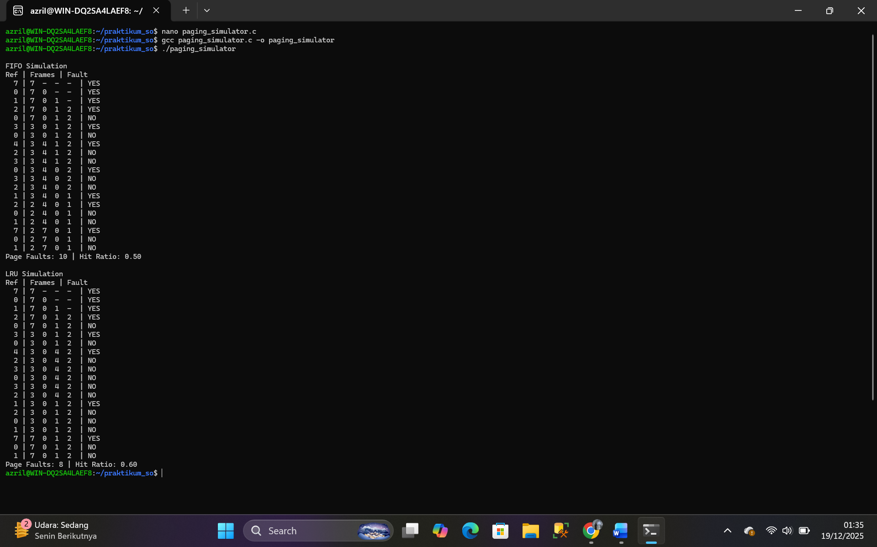

  - Tugas 4
    - Sourse Code :

#include <stdio.h>
#include <stdlib.h>
#include <string.h>

#define L1_BITS 16
#define L2_BITS 8
#define L3_BITS 8
#define OFFSET_BITS 12

#define L1_SIZE (1 << L1_BITS)
#define L2_SIZE (1 << L2_BITS)
#define L3_SIZE (1 << L3_BITS)

#define NUM_FRAMES 128

/* =======================
THREE LEVEL PAGE TABLE
======================= */

typedef struct {
int frame_number;
int valid;
int read, write, execute;
} L3_Entry;

typedef struct {
L3_Entry *entries;
int valid;
} L2_Entry;

typedef struct {
L2_Entry *entries;
int valid;
} L1_Entry;

L1_Entry *page_table;

/* =======================
INVERTED PAGE TABLE
======================= */

typedef struct {
int process_id;
int page_number;
int valid;
} InvertedPageEntry;

InvertedPageEntry inverted_table[NUM_FRAMES];

/* =======================
INIT PAGE TABLE
======================= */

void init_page_table() {
page_table = (L1_Entry *)calloc(L1_SIZE, sizeof(L1_Entry));
}

/* =======================
ALLOCATE 3 LEVEL
======================= */

void allocate_3level(unsigned long virtual_addr, int frame) {
unsigned long l1_index = (virtual_addr >> (L2_BITS + L3_BITS + OFFSET_BITS)) & ((1 << L1_BITS) - 1);
unsigned long l2_index = (virtual_addr >> (L3_BITS + OFFSET_BITS)) & ((1 << L2_BITS) - 1);
unsigned long l3_index = (virtual_addr >> OFFSET_BITS) & ((1 << L3_BITS) - 1);

if (!page_table[l1_index].valid) {
page_table[l1_index].entries = (L2_Entry *)calloc(L2_SIZE, sizeof(L2_Entry));
page_table[l1_index].valid = 1;
}

if (!page_table[l1_index].entries[l2_index].valid) {
page_table[l1_index].entries[l2_index].entries =
(L3_Entry *)calloc(L3_SIZE, sizeof(L3_Entry));
page_table[l1_index].entries[l2_index].valid = 1;
}

L3_Entry *entry = &page_table[l1_index]
.entries[l2_index]
.entries[l3_index];

entry->frame_number = frame;
entry->valid = 1;
entry->read = entry->write = entry->execute = 1;
}

/* =======================
TRANSLATE ADDRESS
======================= */

int translate_3level(unsigned long virtual_addr) {
unsigned long l1_index = (virtual_addr >> (L2_BITS + L3_BITS + OFFSET_BITS)) & ((1 << L1_BITS) - 1);
unsigned long l2_index = (virtual_addr >> (L3_BITS + OFFSET_BITS)) & ((1 << L2_BITS) - 1);
unsigned long l3_index = (virtual_addr >> OFFSET_BITS) & ((1 << L3_BITS) - 1);
unsigned long offset = virtual_addr & ((1 << OFFSET_BITS) - 1);

if (!page_table[l1_index].valid) return -1;
if (!page_table[l1_index].entries[l2_index].valid) return -1;

L3_Entry entry = page_table[l1_index]
.entries[l2_index]
.entries[l3_index];

if (!entry.valid) return -1;

return (entry.frame_number << OFFSET_BITS) | offset;
}

/* =======================
MEMORY OVERHEAD
======================= */

void calculate_memory_overhead() {
int l1_used = 0, l2_used = 0, l3_used = 0;

for (int i = 0; i < L1_SIZE; i++) {
if (page_table[i].valid) {
l1_used++;
for (int j = 0; j < L2_SIZE; j++) {
if (page_table[i].entries[j].valid) {
l2_used++;
for (int k = 0; k < L3_SIZE; k++) {
if (page_table[i].entries[j].entries[k].valid)
l3_used++;
}
}
}
}
}

printf("\n=== MEMORY OVERHEAD ===\n");
printf("L1 entries used : %d\n", l1_used);
printf("L2 entries used : %d\n", l2_used);
printf("L3 entries used : %d\n", l3_used);
}

/* =======================
INVERTED PAGE TABLE
======================= */

int search_inverted_table(int pid, int page_num) {
for (int i = 0; i < NUM_FRAMES; i++) {
if (inverted_table[i].valid &&
inverted_table[i].process_id == pid &&
inverted_table[i].page_number == page_num) {
return i;
}
}
return -1;
}

void insert_inverted_table(int pid, int page_num, int frame) {
inverted_table[frame].process_id = pid;
inverted_table[frame].page_number = page_num;
inverted_table[frame].valid = 1;
}

/* =======================
MAIN
======================= */

int main() {
init_page_table();

unsigned long virtual_address = 0x123456789ABC;
allocate_3level(virtual_address, 42);

int physical = translate_3level(virtual_address);
printf("Virtual Address : 0x%lx\n", virtual_address);
printf("Physical Address : 0x%x\n", physical);

insert_inverted_table(1, 10, 5);
printf("Inverted PT search (PID=1, Page=10): Frame %d\n",
search_inverted_table(1, 10));

calculate_memory_overhead();

return 0;
}

    - Output :
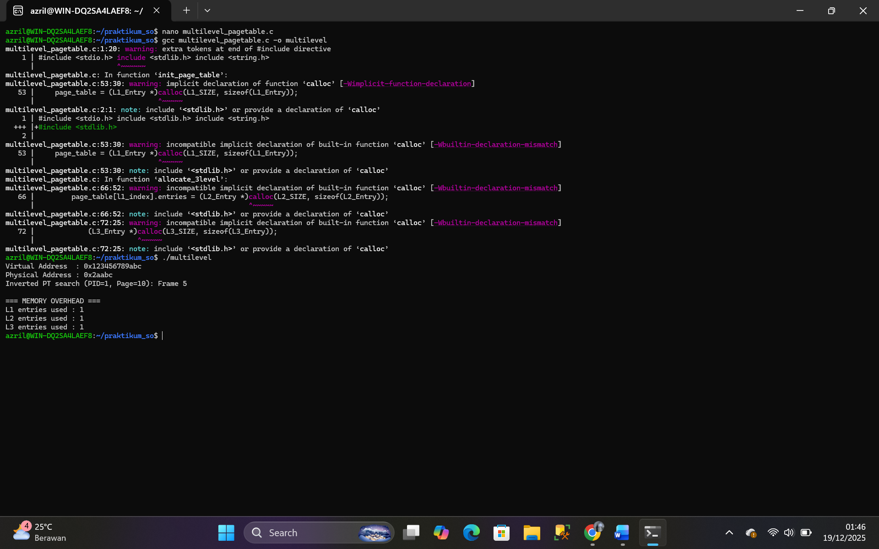

  - Tugas 5
    - Sourse Code :

#include <stdio.h>
#include <stdlib.h>
#include <time.h>

#define MAX_PROCESS 10
#define MEMORY_SIZE 1024 // MB
#define SIMULATION_TIME 100

typedef struct {
int pid;
int size;
int priority;
int in_memory;
int swap_count;
time_t last_access;
time_t load_time;
} Process;

Process processes[MAX_PROCESS];
int used_memory = 0;

/* =======================
SWAP FUNCTIONS
======================= */

void swap_out(Process *p) {
if (p->in_memory) {
p->in_memory = 0;
used_memory -= p->size;
p->swap_count++;
printf("SWAP OUT -> PID %d\n", p->pid);
}
}

void swap_in(Process *p) {
if (!p->in_memory && used_memory + p->size <= MEMORY_SIZE) {
p->in_memory = 1;
used_memory += p->size;
p->load_time = time(NULL);
p->last_access = time(NULL);
printf("SWAP IN -> PID %d\n", p->pid);
}
}

/* =======================
VICTIM SELECTION
======================= */

// FIFO
int select_fifo() {
int victim = -1;
time_t oldest = time(NULL);

for (int i = 0; i < MAX_PROCESS; i++) {
if (processes[i].in_memory && processes[i].load_time < oldest) {
oldest = processes[i].load_time;
victim = i;
}
}
return victim;
}

// LRU
int select_lru() {
int victim = -1;
time_t oldest = time(NULL);

for (int i = 0; i < MAX_PROCESS; i++) {
if (processes[i].in_memory && processes[i].last_access < oldest) {
oldest = processes[i].last_access;
victim = i;
}
}
return victim;
}

// Priority-based (priority kecil = rendah)
int select_priority() {
int victim = -1;
int lowest_priority = 999;

for (int i = 0; i < MAX_PROCESS; i++) {
if (processes[i].in_memory && processes[i].priority < lowest_priority) {
lowest_priority = processes[i].priority;
victim = i;
}
}
return victim;
}

/* =======================
SIMULATION
======================= */

void simulate(int strategy) {
used_memory = 0;
int swap_in_count = 0;
int swap_out_count = 0;

// Reset status
for (int i = 0; i < MAX_PROCESS; i++) {
processes[i].in_memory = 0;
processes[i].swap_count = 0;
}

printf("\n=== SIMULATION START ===\n");

for (int t = 0; t < SIMULATION_TIME; t++) {
int idx = rand() % MAX_PROCESS;
Process *p = &processes[idx];

if (!p->in_memory) {
while (used_memory + p->size > MEMORY_SIZE) {
int victim = -1;

if (strategy == 0) victim = select_fifo();
else if (strategy == 1) victim = select_lru();
else victim = select_priority();

if (victim != -1) {
swap_out(&processes[victim]);
swap_out_count++;
}
}
swap_in(p);
swap_in_count++;
} else {
p->last_access = time(NULL);
}
}

printf("\n=== RESULT ===\n");
printf("Swap In Count : %d\n", swap_in_count);
printf("Swap Out Count : %d\n", swap_out_count);
}

/* =======================
MAIN
======================= */

int main() {
srand(time(NULL));

// Init processes
for (int i = 0; i < MAX_PROCESS; i++) {
processes[i].pid = i + 1;
processes[i].size = 50 + rand() % 151; // 50 - 200 MB
processes[i].priority = 1 + rand() % 5; // 1 - 5
}

printf("\n--- FIFO STRATEGY ---\n");
simulate(0);

printf("\n--- LRU STRATEGY ---\n");
simulate(1);

printf("\n--- PRIORITY STRATEGY ---\n");
simulate(2);

return 0;
}

    - Output :
